

Enon Knight at the Dragons

Friday, June 26th @ 7:05pm
Gates Open 1 Hour prior to first pitch!
Dayton Dragons vs. West Michigan Whitecaps

Tickets are only $15.00 (plus fees)
50% of ticket sales
will be donated back to the Village of Enon

DEADLINE TO PURCHASE:
May 26th, 2026!!

HOW TO ORDER:
Purchase Online:
https://www.gofevo.com/event/EnonKnight2026

-or-

Scan the QR Code!!






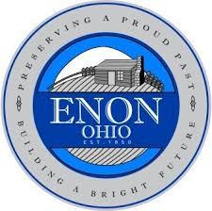
Please contact your ticket representative for any questions/concerns you may have:
Madison Berlinger | madison.berlinger@daytondragons.com | (937)-228-2287 X626

